**PHASE-4 FIRST PROJECT WRITEUP**

**Building A Restaurant Website with Bootstrap.**

DESCRIPTION

**Project objective:**

Build a responsive website for a restaurant where users can read the details of the restaurant.’

**Background of the problem statement:**

You are a web developer at a service-based web development company called Kite Technologies. The company has been approached by a client who wants to build a website for their restaurant named Ming’s Diner. The website should provide the users a brief overview of the restaurant and its bestsellers, its address, as well as an option to contact the restaurant. During sprint planning, you agree to lead this project and develop the website.

**The tasks you are responsible for:**

● Building the website using HTML  
● Adding Bootstrap to the website  
● Adding a landing page, a navbar, a CTA button, a grid, and a footer  
● Adding a contact form for users to contact the restaurant  
● Pushing the code to the git repository

**You must use the following tools:**

● HTML: To define the content of the website  
● Bootstrap: To build the website  
● JavaScript: To handle events and responses  
● JQuery: To include JavaScript plugins like modals, tooltips, etc.

**The following requirements should be met:**

● The website should be responsive.  
● The website should have a carousel, a navbar, a CTA button, a grid, and a footer.   
● The website should have a contact form.  
● The source code should be pushed to your GitHub repositories. You need to document the steps and write the algorithms in the Google Docs.  
● The link of your GitHub repository is must. In order to track your task, you need to share the link of the repository. You can add a section in the Google Docs.   
● Document the step-by-step process involved in completing this task.

[**HTML:**](https://www.geeksforgeeks.org/html-tutorials/)HTML stands for Hyper Text Markup Language. It is used to design web pages using a markup language. HTML is the combination of Hypertext and Markup language. Hypertext defines the link between the web pages. A markup language is used to define the text document within tag which defines the structure of web pages.

[**CSS:**](https://www.geeksforgeeks.org/css-tutorials/) Cascading Style Sheets, fondly referred to as CSS, is a simply designed language intended to simplify the process of making web pages presentable. CSS allows you to apply styles to web pages. More importantly, CSS enables you to do this independent of the HTML that makes up each web page.

[**BOOTSTRAP :**](https://www.geeksforgeeks.org/bootstrap-tutorials/)Bootstrap is a free and open-source tool collection for creating responsive websites and web applications. It is the most popular HTML, CSS, and JavaScript framework for developing responsive, mobile-first web sites. Nowadays, the websites are perfect for all the browsers (IE, Firefox and Chrome) and for all sizes of screens (Desktop, Tablets, and Phones). All thanks to Bootstrap developers – Mark Otto and Jacob Thornton of Twitter, though it was later declared to be an open-source project.

**HTML section:** File name is index.html

<!DOCTYPE html>

<html>

<head>

<title>Ming's Diner Restaurant Website</title>

<meta charset="UTF-8">

<meta name="viewport" content="width=device-width, initial-scale=1">

<link rel="stylesheet" href="https://www.w3schools.com/w3css/4/w3.css">

<link rel="stylesheet" href="https://fonts.googleapis.com/css?family=Big+Shoulders+Text">

<!-- Bootstrap CSS -->

<link rel="stylesheet" href=

"https://stackpath.bootstrapcdn.com/bootstrap/4.3.1/css/bootstrap.min.css"

    integrity=

"sha384-ggOyR0iXCbMQv3Xipma34MD+dH/1fQ784/j6cY/iJTQUOhcWr7x9JvoRxT2MZw1T"

    crossorigin="anonymous">

<style>

body, html {height: 100%}

body,h1,h2,h3,h4,h5,h6 {font-family: "Big Shoulders Text", sans-serif}

.menu {display: none}

.bgimg {

  background-repeat: no-repeat;

  background-size: cover;

  background-image: url("restaurant.jpg");

  min-height: 100%;

}

</style>

</head>

<body>

<!-- Navbar (sit on top) -->

<div class="w3-top w3-hide-small">

  <div class="w3-bar w3-xlarge w3-black w3-opacity w3-hover-opacity-off " id="myNavbar">

    <a href="#" class="w3-bar-item w3-button">HOME</a>

    <a href="#menu" class="w3-bar-item w3-button">MENU</a>

    <a href="#about" class="w3-bar-item w3-button">ABOUT</a>

    <a href="#myMap" class="w3-bar-item w3-button">CONTACT</a>

  </div>

</div>

<!-- Header with image -->

<header class="bgimg w3-display-container w3-grayscale-min" id="home">

  <div class="w3-display-bottomleft w3-padding">

    <span class="w3-tag w3-xlarge">Open from 10am to 12pm</span>

  </div>

  <div class="w3-display-middle w3-center">

      <marquee> <span class="w3-text-green" style="font-size:100px"><br>Welcome To Ming's Diner</span></marquee>

    <p><a href="#menu" class="w3-button w3-xxlarge w3-black">Let me see the menu</a></p><br>

    <p><a href="#myMap" class="w3-button w3-xxlarge w3-black">Book A Table</a></p>

  </div>

</header>

<!-- Menu Container -->

<div class="w3-container w3-black w3-padding-64 w3-xxlarge" id="menu">

  <div class="w3-content">

    <h1 class="w3-center w3-jumbo" style="margin-bottom:64px">THE MENU</h1>

    <div class="w3-row w3-center w3-border w3-border-dark-grey">

      <a href="javascript:void(0)" onclick="openMenu(event, 'Pizza');" id="myLink">

        <div class="w3-col s4 tablink w3-padding-large w3-hover-red">Pizza</div>

      </a>

      <a href="javascript:void(0)" onclick="openMenu(event, 'Pasta');">

        <div class="w3-col s4 tablink w3-padding-large w3-hover-red">Salads</div>

      </a>

      <a href="javascript:void(0)" onclick="openMenu(event, 'Starter');">

        <div class="w3-col s4 tablink w3-padding-large w3-hover-red">Starter</div>

      </a>

    </div>

    <div id="Pizza" class="w3-container menu w3-padding-32 w3-white">

      <h1><b>Margherita</b> <span class="w3-right w3-tag w3-dark-grey w3-round">$12.50</span></h1>

      <p class="w3-text-grey">Fresh tomatoes, fresh mozzarella, fresh basil</p>

      <hr>

      <h1><b>Formaggio</b> <span class="w3-right w3-tag w3-dark-grey w3-round">$15.50</span></h1>

      <p class="w3-text-grey">Four cheeses (mozzarella, parmesan, pecorino, jarlsberg)</p>

      <hr>

      <h1><b>Chicken</b> <span class="w3-right w3-tag w3-dark-grey w3-round">$17.00</span></h1>

      <p class="w3-text-grey">Fresh tomatoes, mozzarella, chicken, onions</p>

      <hr>

      <h1><b>Pineapple'o'clock</b> <span class="w3-right w3-tag w3-dark-grey w3-round">$16.50</span></h1>

      <p class="w3-text-grey">Fresh tomatoes, mozzarella, fresh pineapple, bacon, fresh basil</p>

      <hr>

      <h1><b>Meat Town</b> <span class="w3-tag w3-red w3-round">Hot!</span><span class="w3-right w3-tag w3-dark-grey w3-round">$20.00</span></h1>

      <p class="w3-text-grey">Fresh tomatoes, mozzarella, hot pepporoni, hot sausage, beef, chicken</p>

      <hr>

      <h1><b>Parma</b> <span class="w3-tag w3-grey w3-round">New</span><span class="w3-right w3-tag w3-dark-grey w3-round">$21.50</span></h1>

      <p class="w3-text-grey">Fresh tomatoes, mozzarella, parma, bacon, fresh arugula</p>

    </div>

    <div id="Pasta" class="w3-container menu w3-padding-32 w3-white">

      <h1><b>Lasagna</b> <span class="w3-tag w3-grey w3-round">Popular</span> <span class="w3-right w3-tag w3-dark-grey w3-round">$13.50</span></h1>

      <p class="w3-text-grey">Special sauce, mozzarella, parmesan, ground beef</p>

      <hr>

      <h1><b>Ravioli</b> <span class="w3-right w3-tag w3-dark-grey w3-round">$14.50</span></h1>

      <p class="w3-text-grey">Ravioli filled with cheese</p>

      <hr>

      <h1><b>Spaghetti Classica</b> <span class="w3-right w3-tag w3-dark-grey w3-round">$11.00</span></h1>

      <p class="w3-text-grey">Fresh tomatoes, onions, ground beef</p>

      <hr>

      <h1><b>Seafood pasta</b> <span class="w3-right w3-tag w3-dark-grey w3-round">$25.50</span></h1>

      <p class="w3-text-grey">Salmon, shrimp, lobster, garlic</p>

    </div>

    <div id="Starter" class="w3-container menu w3-padding-32 w3-white">

      <h1><b>Today's Soup</b> <span class="w3-tag w3-grey w3-round">Seasonal</span><span class="w3-right w3-tag w3-dark-grey w3-round">$5.50</span></h1>

      <p class="w3-text-grey">Ask the waiter</p>

      <hr>

      <h1><b>Bruschetta</b> <span class="w3-right w3-tag w3-dark-grey w3-round">$8.50</span></h1>

      <p class="w3-text-grey">Bread with pesto, tomatoes, onion, garlic</p>

      <hr>

      <h1><b>Garlic bread</b> <span class="w3-right w3-tag w3-dark-grey w3-round">$9.50</span></h1>

      <p class="w3-text-grey">Grilled ciabatta, garlic butter, onions</p>

      <hr>

      <h1><b>Tomozzarella</b> <span class="w3-right w3-tag w3-dark-grey w3-round">$10.50</span></h1>

      <p class="w3-text-grey">Tomatoes and mozzarella</p>

    </div><br>

  </div>

</div>

<!-- About Container -->

<div class="w3-container w3-padding-64 w3-red w3-grayscale w3-xlarge" id="about">

  <div class="w3-content">

    <h1 class="w3-center w3-jumbo" style="margin-bottom:64px">About</h1>

    <p>The Ming's Diner was founded in 1978 by Mr. Italiano. The fascinating worlds they have created range from romantic to historical, lavish to downtown, filmy to serene, even charming to quirky; spoiling their customers for choice while giving them a larger-than-life dining experience. Needless to say, the impeccable taste, quality and service have made it a benchmark for culinary excellence, leading to a prolonged patronage for the brand. The underlying idea is to give diners an experience to relish and cherish, as is advocated in its slogan "Happy Dining".</p>

    <p><strong>The Chef?</strong> Mr. Italiano himself<img src="chef.jpg" style="width:150px" class="w3-circle w3-right" alt="Chef"></p>

    <p>We are proud of our interiors.</p>

    <img src="onepage_restaurant.jpg" style="width:100%" class="w3-margin-top w3-margin-bottom" alt="Restaurant">

    <!-- carousel section -->

<div id="carouselExampleControls"

class="carousel slide" data-ride="carousel">

<div class="carousel-inner">

  <div class="carousel-item active">

    <img src="food1.png"

      class="d-block w-100" alt="food">

  </div>

  <div class="carousel-item">

    <img src="food2.png"

      class="d-block w-100" alt="food">

  </div>

  <div class="carousel-item">

    <img src="food3.png"

      class="d-block w-100" alt="food">

  </div>

  <div class="carousel-item">

    <img src="Types-of-Pizza.jpg"

      class="d-block w-100" alt="food">

  </div>

</div>

<a class="carousel-control-prev"

href="#carouselExampleControls"

role="button" data-slide="prev">

<span class="carousel-control-prev-icon"

  aria-hidden="true">

</span>

<span class="sr-only">Previous</span>

</a>

<a class="carousel-control-next"

href="#carouselExampleControls"

role="button" data-slide="next">

<span class="carousel-control-next-icon"

  aria-hidden="true">

</span>

<span class="sr-only">Next</span>

</a>

</div>

    <h1><b>Opening Hours</b></h1>

    <div class="w3-row">

      <div class="w3-col s6">

        <p>Mon & Tue 12.00 - 24.00</p>

        <p>Wednesday 10.00 - 24.00</p>

        <p>Thursday 10:00 - 24:00</p>

      </div>

      <div class="w3-col s6">

        <p>Friday 10:00 - 12:00</p>

        <p>Saturday 10:00 - 23:00</p>

        <p>Sunday Closed</p>

      </div>

    </div>

  </div>

</div>

<!-- Image of location/map -->

<img src="map.jpg" class="w3-image w3-greyscale" style="width:100%;" id="myMap">

<!-- Contact -->

<div class="w3-container w3-padding-64 w3-blue-grey w3-grayscale-min w3-xlarge">

  <div class="w3-content">

    <h1 class="w3-center w3-jumbo" style="margin-bottom:64px">Contact</h1>

    <p>Find us at address<br>

        <span>16 Florida Ave</span><br>

        <span>Palo-Alto, 1111 CA</span><br>

        <span> or call us at 420-503-9009</span><br>

</p>

    <p><span class="w3-tag">FYI!</span> We offer full-service catering for any event, large or small. We understand your needs and we will cater the food to satisfy the biggerst criteria of them all, both look and taste.</p>

    <p class="w3-xxlarge"><strong>Reserve</strong> a table, ask for today's special or just send us a message:</p>

    <form action="/action_page.php" target="_blank">

      <p><input class="w3-input w3-padding-16 w3-border" type="text" placeholder="Name" required name="Name"></p>

     <p><input class="w3-input w3-padding-16 w3-border" class="form-control" placeholder="Enter your phone number" name="InputphoneNumber1" ></p>

      <p><input class="w3-input w3-padding-16 w3-border" type="number" placeholder="How many people" required name="People"></p>

      <p><input class="w3-input w3-padding-16 w3-border" type="datetime-local" placeholder="Date and time" required name="date" value="2022-07-22T20:00"></p>

      <p><input class="w3-input w3-padding-16 w3-border" type="text" placeholder="Message \ Special requirements" required name="Message"></p>

      <p><button class="w3-button w3-light-grey w3-block" type="submit">SEND MESSAGE</button></p>

    </form>

  </div>

</div>

<!-- Footer -->

<footer class="w3-center w3-black w3-padding-48 w3-xxlarge">

  <p>Powered by <a href="Kite Technologies" title="Kite Technologies" target="_blank" class="w3-hover-text-green">Kite Technologies</a></p>

</footer>

  <!-- Optional JavaScript -->

  <!-- jQuery first, then Popper.js, then Bootstrap JS -->

  <script src="https://code.jquery.com/jquery-3.3.1.slim.min.js"

    integrity=

"sha384-q8i/X+965DzO0rT7abK41JStQIAqVgRVzpbzo5smXKp4YfRvH+8abtTE1Pi6jizo"

    crossorigin="anonymous">

  </script>

  <script src=

"https://cdnjs.cloudflare.com/ajax/libs/popper.js/1.14.7/umd/popper.min.js"

    integrity=

"sha384-UO2eT0CpHqdSJQ6hJty5KVphtPhzWj9WO1clHTMGa3JDZwrnQq4sF86dIHNDz0W1"

    crossorigin="anonymous">

  </script>

  <script src=

"https://stackpath.bootstrapcdn.com/bootstrap/4.3.1/js/bootstrap.min.js"

    integrity=

"sha384-JjSmVgyd0p3pXB1rRibZUAYoIIy6OrQ6VrjIEaFf/nJGzIxFDsf4x0xIM+B07jRM"

    crossorigin="anonymous">

  </script>

    <script>

// Tabbed Menu

function openMenu(evt, menuName) {

  var i, x, tablinks;

  x = document.getElementsByClassName("menu");

  for (i = 0; i < x.length; i++) {

     x[i].style.display = "none";

  }

  tablinks = document.getElementsByClassName("tablink");

  for (i = 0; i < x.length; i++) {

     tablinks[i].className = tablinks[i].className.replace(" w3-red", "");

  }

  document.getElementById(menuName).style.display = "block";

  evt.currentTarget.firstElementChild.className += " w3-red";

}

document.getElementById("myLink").click();

</script>

</body>

</html>

Execute the program:

For executing the program, run the index.html file and the output is shown in the web browser.

When the user clicks the HOME button, it will show home page as below

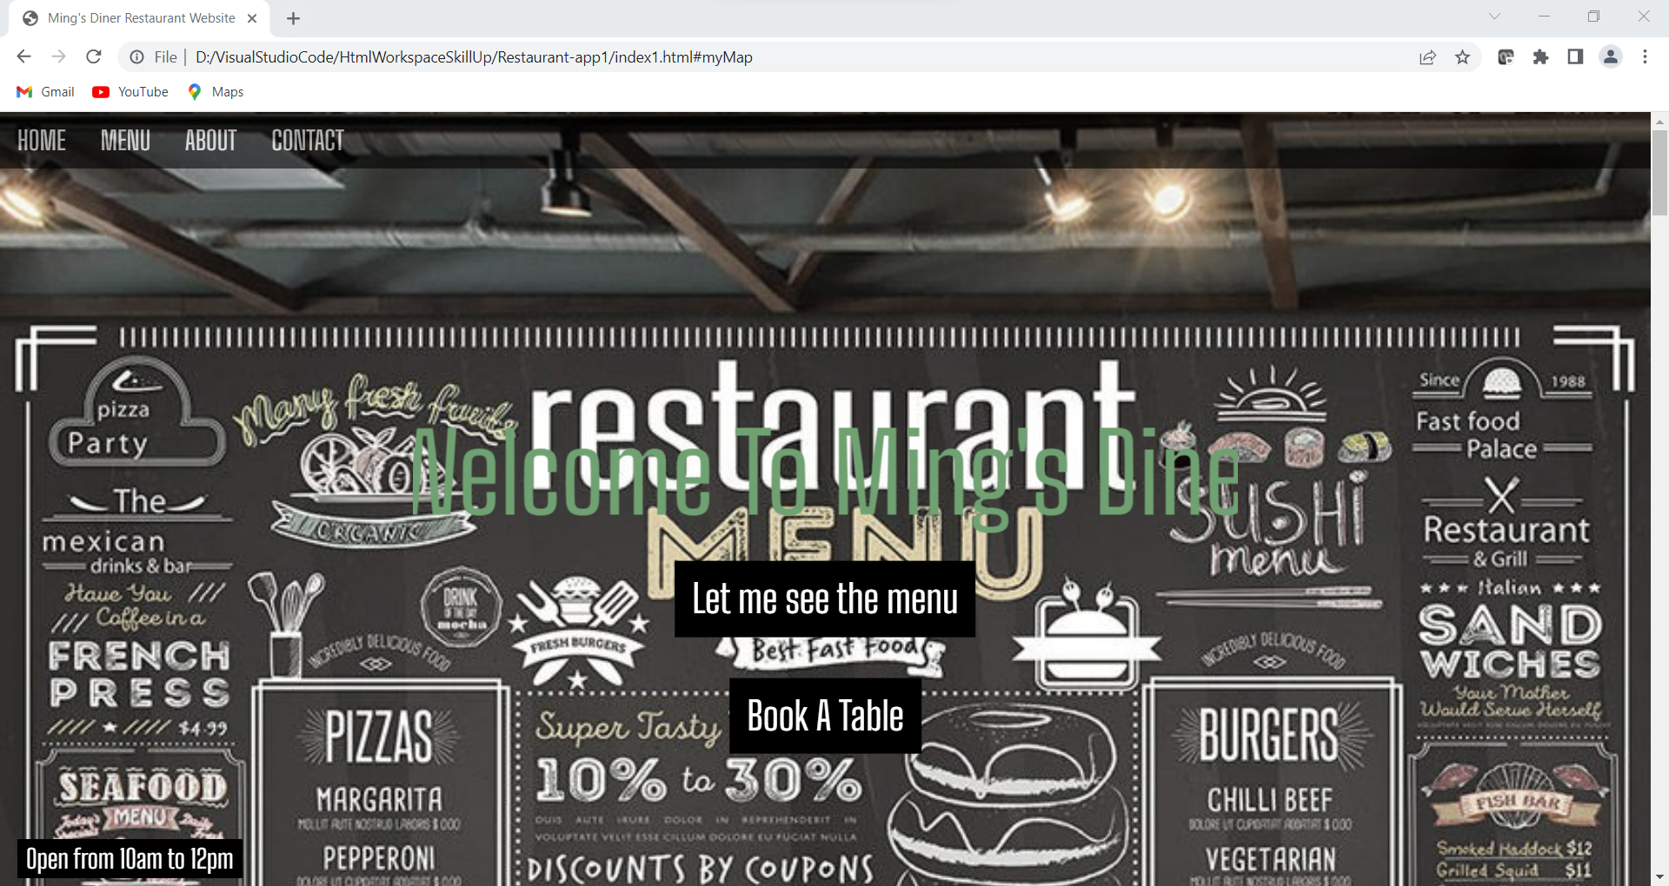

When the user clicks the MENU button or LET ME SEE THE MENU button, it will show Menu page as below

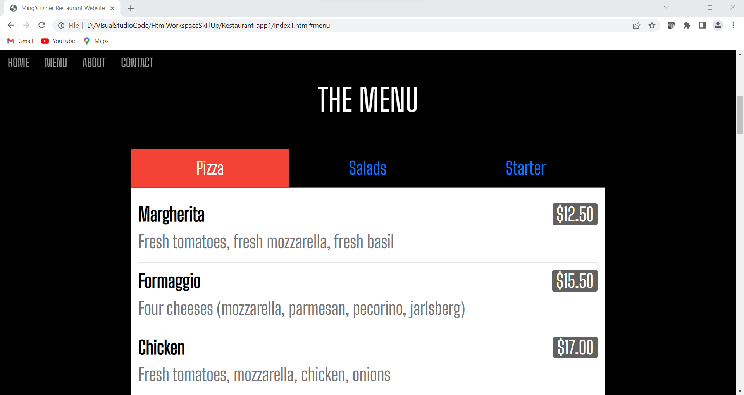

When the user clicks the ABOUT button, it will show About page as below

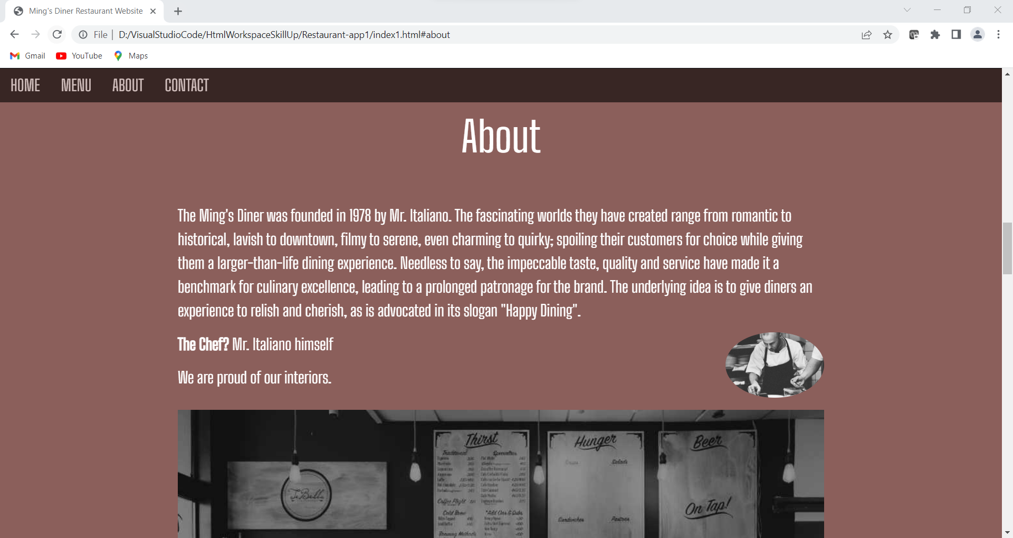

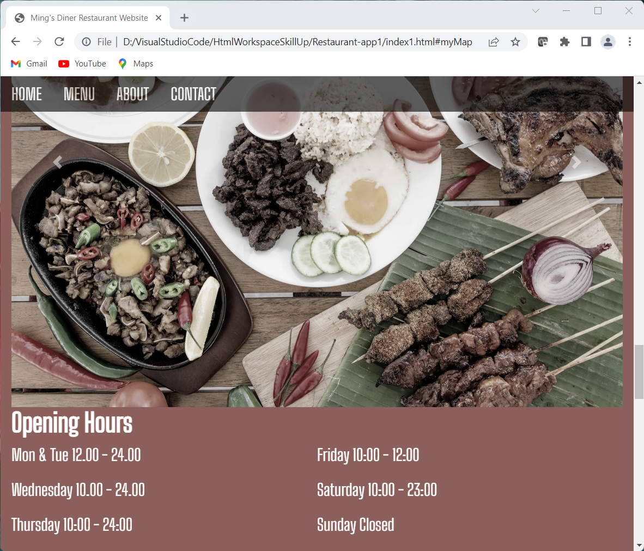

When the user clicks the CONTACT button or BOOK A TABLE button, it will show Contact page as below

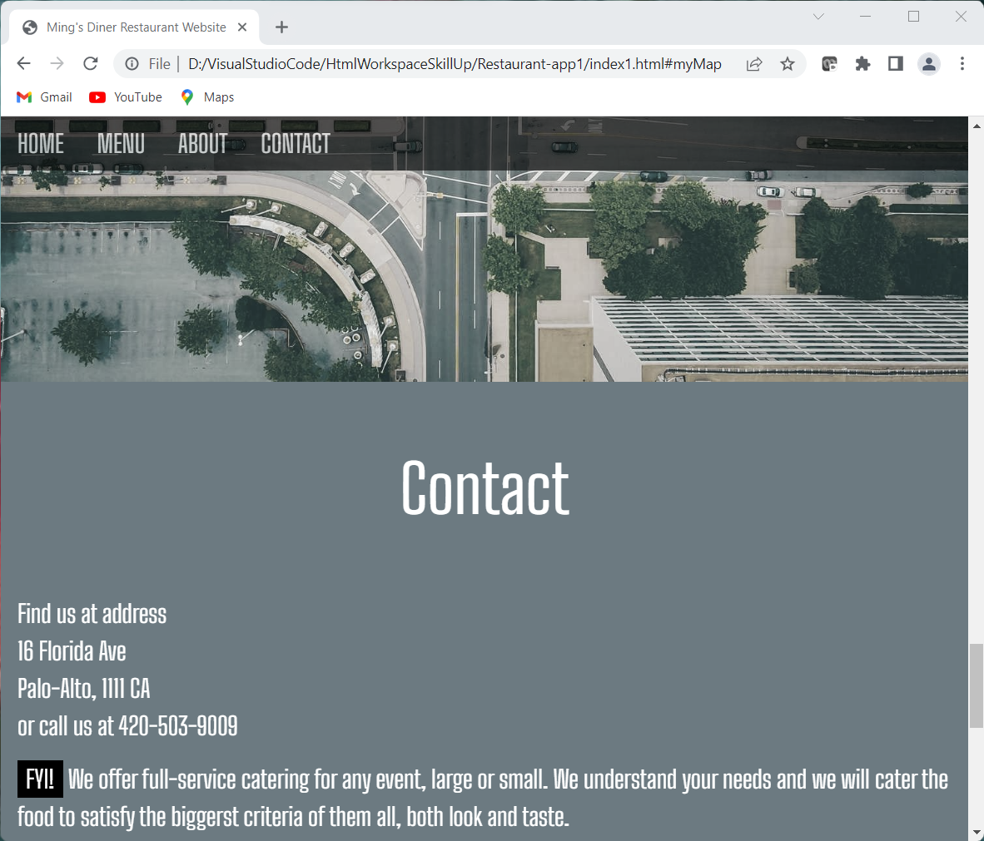

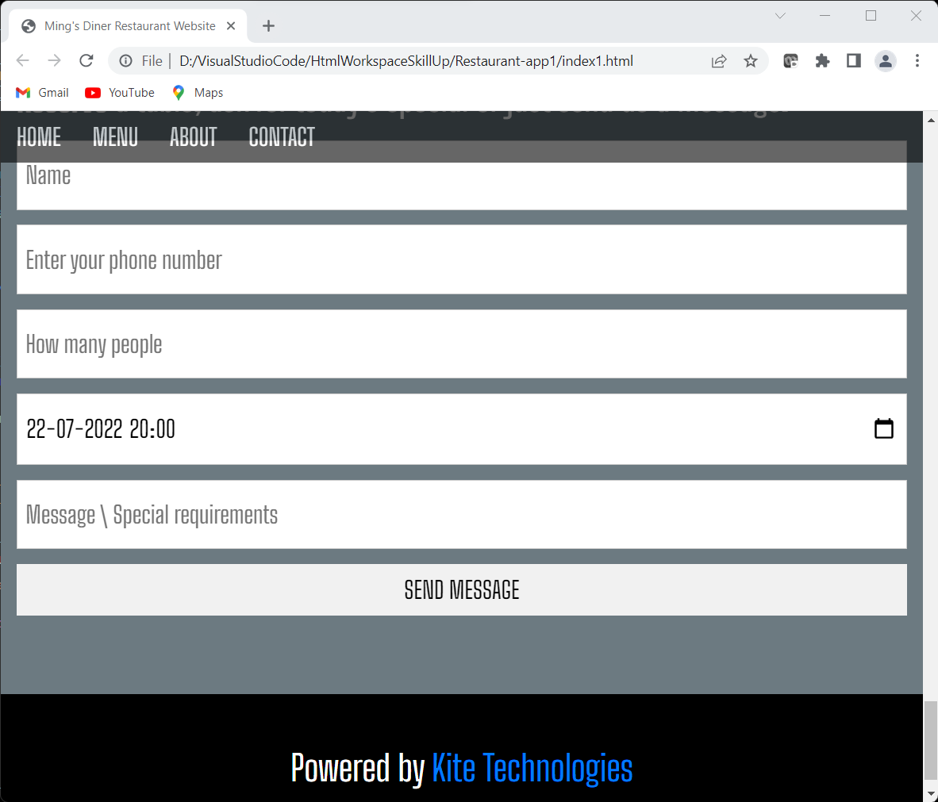

Conclusion:

The website is responsive.  
The website has a carousel, a navbar, a CTA button, a grid, and a footer.   
The website has a contact form.

**Pushing the code to your GitHub repositories:**

* Open your command prompt and navigate to the folder where you have created your files.

**cd <folder path>**

* Initialize your repository using the following command:

**git init**

* Add all the files to your git repository using the following command:

**git add .**

* Commit the changes using the following command:

**git commit . -m “Changes have been committed.”**

* Push the files to the folder you initially created using the following command:

**git push -u origin master**